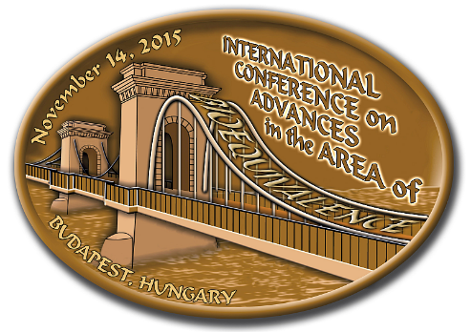 | International Conference  on Advances in the Area of Bioequivalence  Hotel Danubius Health Spa Resort Margitsziget^{****Superior}  Margaret Island, Budapest, Hungary November 14, 2015

Sponsorship and Exhibition Order Form

(Please return this form preferably before October 31, 2015)

Name of the company:

Postal address:

Invoice address (if different from above):

Name of the contact person:

Phone: Fax: E-mail:

VAT Number:

Please tick the appropriate boxes

1. Sponsorship categories

Main Package 3600 EUR+VAT 

Gold Package 2600 EUR+VAT 

Silver Package 1600 EUR+VAT 

2. Sponsoring Opportunities and Benefits
Sponsorship of Banquet Dinner 1500 EUR+VAT 
Sponsorship of Lunch 1300 EUR+VAT 
Sponsorship of Coffee Breaks 500 EUR+VAT /break 
Sponsorship of the Delegates’ Folder 1100 EUR+VAT 
Sponsorship of Name Badges and Lanyards 1100 EUR+VAT 
Sponsorship of Notepaper and Pens 1100 EUR+VAT 
3. Advertisements

Final Program

Inner page A5 (full color) 350 EUR+VAT 

Flyer insert (in the conference bag) 200 EUR +VAT/insert 

4. Exhibition
Size of the stand place (width x depth)

4 m² (~2x2 m) 600 EUR+VAT 

6 m² (~3x2 m) 800 EUR+VAT 

5. Prices and payment conditions

All prices stated above exclude VAT, which is 27 % (as of 2015). Payment should be arranged upon receipt of our
pro forma invoice, according to the following terms:

Deadline of sponsorship and advertisement fees October 31, 2015

Payment should be arranged upon receipt of our pro forma invoice.

6. Cancellation Policy

Cancellation is not possible from the side of the sponsor, after having sent the expression of intent, as the service (communication towards the participants) is started by the organizers immediately.
Refundable amounts depend on the date of cancellation and are stated as follows:

Before November 7, 2015: 50% refunded, 50% retained
After November 7, 2015: no refund.

By signing this application form, I hereby declare that I understand and accept the conditions of participation, payment and cancellation.

Date: ……………………..………. Signature: …………………………………………..

Please send this form to the Symposium Secretariat preferably before October 31, 2015.

Diamond Congress Ltd.
H-1255 Budapest, P.O. Box 48
Phone: +36 1 225 0210 Fax: +36 1 201 2680
E-mail: diamond@diamond-congress.hu
http://icab2015.hu

